Current Activities & Acquisitions
We continue to receive donations, principally from ex-IBMers, of many items of interest. Since the last update this has included a number of ThinkPads, the contents of two racks of redundant communications equipment from Warwick, three oscilloscopes, a box of unused punch cards, and miscellaneous hardware parts, software and hard copy.

New Display Items
Two items of storage used in System/360 have been identified and added to the S/360 display cabinet. These are a single card of Card Capacitor Read Only Storage (CCROS) from a Model 30 and a piece of Capacitive Read Only Storage (CROS), developed in Hursley, from the Model 50.
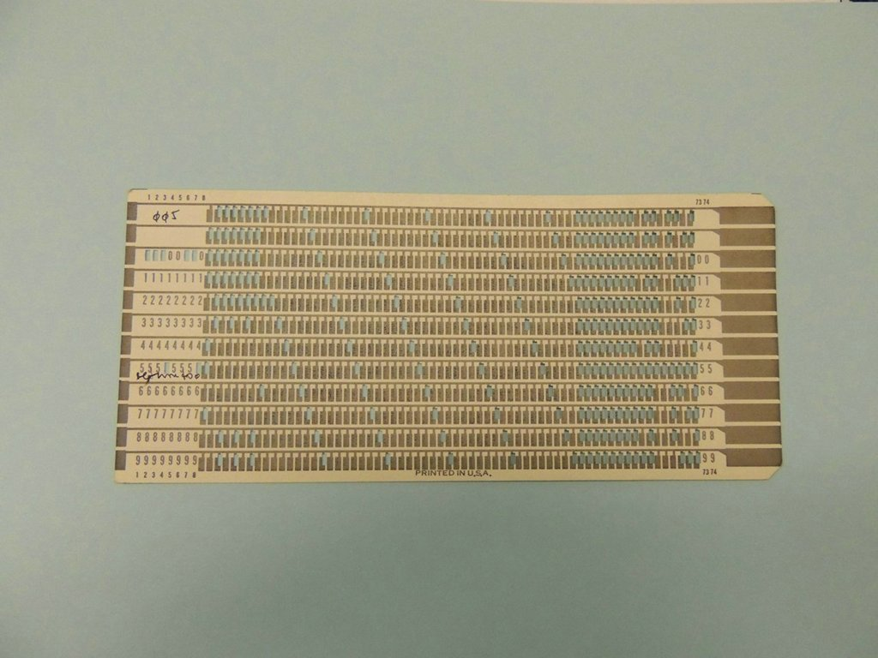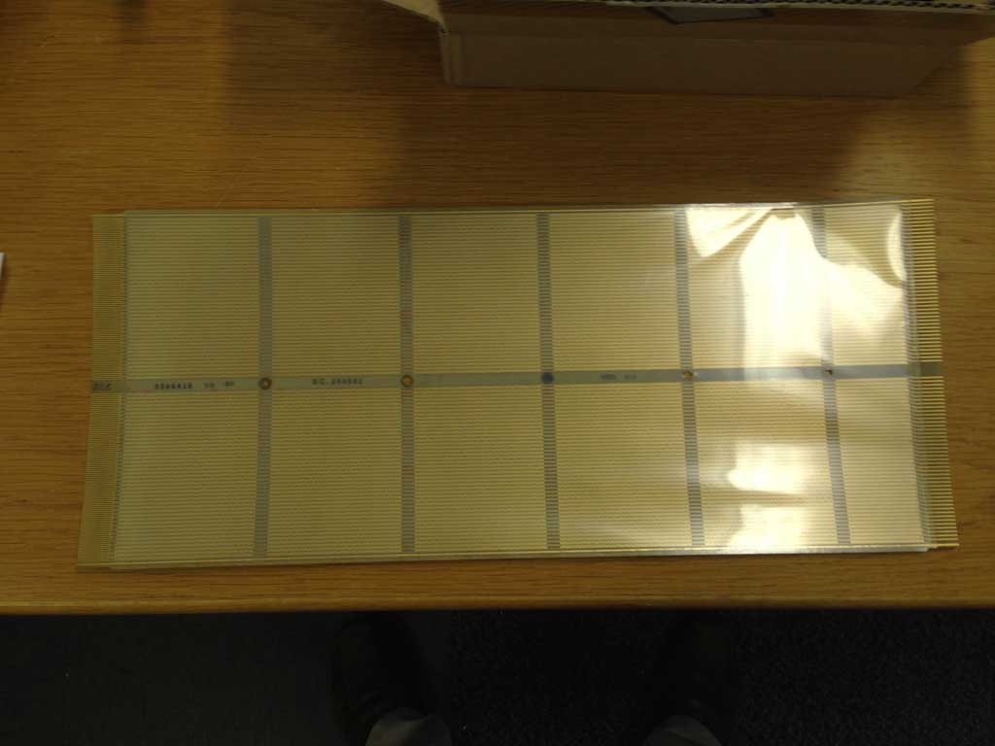
CCROS CROS

The mock-up of the IBM2984 Cashpoint is complete and out on display.
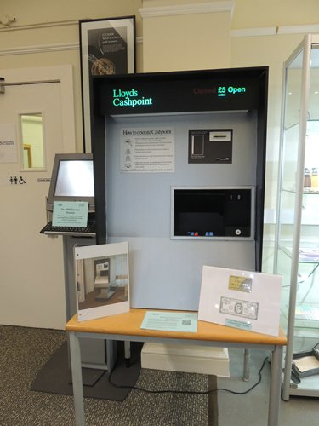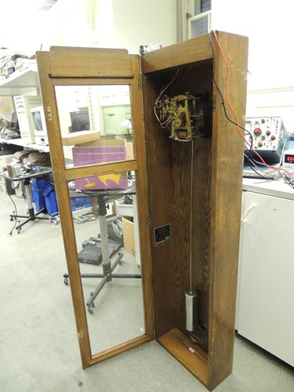

Other
We have obtained a variable voltage power supply, which will help us to get some of our old IBM clocks working. These clocks are wound by a solenoid, running on 24 volts and activated once a minute. The clock shown here, without its face and hands, is working well, although the contact that powers the solenoid is proving unreliable. In anticipation of sorting this issue and getting at least one more clock up and running we’ve bought a couple of small, fixed 24 volt power supplies from eBay.

We recently donated a PS/2 P75 portable to a collector and are preparing a number of items to be shipped to the Manchester UK Labs Campus for a new display in reception.

